NATIONAL JUNIOR COLLEGE
PRELIMINARY EXAMINATIONS
Higher 2
CANDIDATE
NAME

SUBJECT  CLASS |  | REGISTRATION NUMBER

CHEMISTRY  Paper 3 Free response | 9647/03  Mon 13 Sep 2010  2 hours

READ THESE INSTRUCTIONS FIRST

Answer any four questions.

Start your answer to each question on a fresh piece of paper.

A Data Booklet is provided.

You are reminded of the need for good English and clear presentation in your answers.

The number of marks is given in brackets [ ] at the end of each question or part question.

At the end of the examination, fasten all your work securely behind the cover page.

This paper consists of 13 printed pages and 0 blank page.

Answer any four questions.

1. Potassium fluoride is prepared by dissolving potassium carbonate in excess hydrofluoric acid. Evaporation of the solution forms crystals of potassium bifluoride, KHF₂. The bifluoride on heating yields potassium fluoride and hydrogen fluoride:

K₂CO₃(s) + 4 HF (aq) → 2 KHF₂ (aq) + CO₂ (g) + H₂O (l)
KHF₂ (s) → KF (s) + HF(g)

(a) (i) Draw a diagram to illustrate the bonding in potassium bifluoride, KHF₂.

(ii) By reference to their structures and bonding, explain why carbon dioxide is a gas while water is a liquid at room temperature and pressure.
[4]

(b) A student was asked to determine the standard enthalpy change of formation of solid potassium carbonate. When he dissolved 5.00 g of solid potassium carbonate in 100 cm³ of water, the temperature increased from 27.0 ºC to 30.0 ºC.

- Define the standard enthalpy change of formation of solid potassium carbonate.

- Using the data above, determine the enthalpy change of solution of potassium carbonate.

- Using your answer from (b)(ii) and the following information,

 | ΔH_{f} / kJ mol^{–1}
K⁺ (aq) | –252
CO₃^{2–}(aq) | –677

determine the standard enthalpy change of formation of solid potassium carbonate.
[6]

1. (c) The water-gas shift reaction is an important industrial reaction, used in conjunction with steam reforming of methane and other hydrocarbons. Carbon monoxide reacts with water vapour to form carbon dioxide and hydrogen in the water-gas shift reaction over Fe₃O₄ catalyst. The uncatalysed reaction has an activation energy of 25 kJ mol⁻¹.
CO(g) + H₂O(g) CO₂ (g) + H₂(g) ΔH= − 41 kJ mol⁻¹
A mixture containing a 1:2 ratio of CO and H₂O was allowed to reach equilibrium at 6.0 atm at 400 K. At equilibrium, the partial pressure of H₂ was found to be 1.5 atm.
(i) Use the data provided to construct a labelled reaction pathway diagram for the uncatalysed reaction.
(ii) Explain how Fe₃O₄ functions as a catalyst in this reaction.

(iii) With an appropriate sketch of the Boltzmann distribution, describe how a catalyst speeds up a chemical reaction.

(iv) Calculate the partial pressures of CO, CO₂ and H₂O at equilibrium, and hence calculate the equilibrium constant, K_{p}, at 400 K.

(v) State and explain how the equilibrium mixture in (c) will respond when aqueous sodium hydroxide is added to it.

[10]

[Total: 20]

2. Progesterone and testosterone are the respective female and male sex hormones while oxometholone, with a similar structure to testosterone, is an anabolic steroid which builds up muscle.

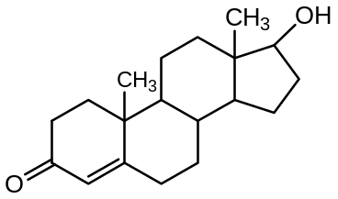
testosterone

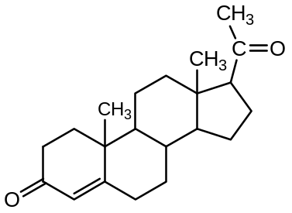 | 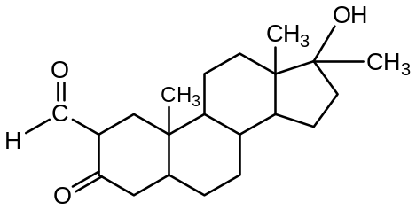
progesterone | oxometholone

(a) (i) Name the functional groups present in testosterone.

(ii) Draw the structural formula of the organic product formed when testosterone is treated with ethanolic NaBH₄.

(iii) Would testosterone exhibit geometric isomerism? Explain your answer.
[5]

(b) Fehling’s solution, an alkaline solution of copper(II) tartarate, can be used to distinguish oxometholone from the other two compounds.

(i) State the observations when oxometholone reacts with Fehling’s solution.

(ii) Suggest a test-tube reaction which would enable you to distinguish progesterone from the other two compounds.

Describe the observations you would expect to see.

[3]

2. (c) An blue solution A contains a mixture of Cu²⁺ and Mg²⁺ ions. The scheme below shows the reaction of A with aqueous ammonia.

A
Blue solution solution
C
dark blue solution
excess
NH₃ (aq)
filter
D
Yellow solution
Concentrated HCl (aq)
B
white residue

(i) Identify the chemical species present in B and D.

(ii) Explain why solution A is blue.

(iii) Explain, as fully as you can, the difference in the colours of solutions A and C.

[7]

- The following table lists the solubility products of two compounds at 25ºC.

Compound | Solubility Product
Cu(OH)₂ | 1.8 × 10⁻²⁰
Mg(OH)₂ | 1.8 × 10⁻¹¹

(i) By considering the relative ionic radius of Cu²⁺ and Mg²⁺, explain the difference in the solubilities of copper(II) hydroxide, Cu(OH)₂ and magnesium hydroxide, Mg(OH)₂.

(ii) Calculate the solubility of copper(II) hydroxide in 0.5 mol dm⁻³ NaOH solution.

(iii) How would you expect the solubility of copper(II) hydroxide in water to differ from your answer to (d)(ii)? Explain.
[5]

[Total: 20]

3. The titration curve below shows the neutralization reaction between 10.0 cm³ of a 0.10 mol dm⁻³ phosphoric acid, H₃PO₄ with a 0.10 mol dm⁻³ NaOH. Two significant pH values are given.

pH
Volume of NaOH added/cm³
0 5.0 10.0 15.0 20.0
7.2
2.2
E
F

Use of the above sketch is relevant to parts (a) and (b).

(a) (i) What does the pH value of 2.2 represent in the titration curve above?

- Calculate the initial pH of phosphoric acid at E.

(iii) Give the formula of the chemical species present at F.
[4]

(b) Majority of biological samples used in research are made in buffers, especially phosphate buffered saline at pH 7.4. 1 dm³ of this buffer can be made by dissolving 8.00 g NaCl, 1.44 g Na₂HPO₄ and 2.56 g NaH₂PO₄ in 1 dm³ of distilled water.

The pH of this mixture is then adjusted to pH 7.4 by adding a suitable amount of solid NaOH.

- By means of a balanced equation, show how the mixture above can act as a buffer when a few drops of aqueous NaOH are added to it.

(ii) Calculate the mass of solid NaOH that must be added to the mixture so that a pH of 7.4 is achieved.
[4]

3. (c) When neutralized suitably by ammonia, phosphoric acid forms diammonium hydrogen phosphate which is a crystalline white solid commonly used as fertilizer. It undergoes a dissociation as shown:
(NH₄)₂HPO₄(s) 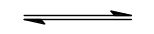NH₃(g) + NH₄H₂PO₄(s)
When applied as plant food, diammonium hydrogen phosphate temporarily increases the soil pH, but over a long term, the treated ground becomes more acidic than before.

Explain why the pH changes described in the underlined statement happens in the soil when diammonium hydrogen phosphate fertilizer is applied to it.
[2]

(d) A fuel cell is an electrochemical cell that converts a fuel into an electrical current. Phosphoric acid fuel cells (PAFC) are a type of fuel cell that uses liquid phosphoric acid as an electrolyte. As phosphoric acid solidifies at 40º C, the operating temperature for the cell is in the range of 150 – 200 ºC. The electrodes are made of carbon paper coated with a finely dispersed platinum catalyst. The platinum catalyst is an efficient material for the oxidation of small organic molecules.

The diagram below illustrates the functional parts of a PAFC, using ethanol as a fuel.
External circuit

excess C₂H₅OH
H₂O
Heat

anode
cathode

H₃PO₄(l)

C₂H₅OH
H₂O
air

The liquid ethanol (C₂H₅OH) is oxidized at the anode in the presence of water and the platinum catalyst, generating CO₂ and hydrogen ions. Hydrogen ions travel through the electrolyte. They react at the cathode with oxygen from the air forming water.

3 (d) (i) Give the two electrode equations, and hence write the overall equation.
(ii) Suggest why phosphoric acid is a suitable electrolyte for this fuel cell.
(iii) Why do you think the electrodes are made of carbon paper? Why is it coated with platinum?
(iv) The main disadvantage of PACF is its high operating cost. State two ways which have made the cost of running PACF high.
[7]

3. (e) Ethanol is also used as a fuel in industry as its combustion in oxygen provides a good source of heat energy.

Calculate, using relevant information from the Data Booklet, the usable heat energy obtained when 1 mole of gaseous ethanol is burnt in excess oxygen, assuming that the process is 75% efficient.
[3]

[Total: 20]

4. Chlorine was identified as an element in 1810 by the English Chemist Sir Humphry Davy. The reactions of chlorine-containing compounds span all fields of chemistry.

- (i) Chlorine reacts with elements from Group V to give trihalides.

The trihalides of nitrogen and phosphorus each react with water in different ways to give two products. Phosphorus trichloride, PCl₃, reacts to give the dibasic acid, H₃PO₃, and a chlorine-containing product whereas nitrogen trichloride, NCl₃, produces HOCl as the only chlorine-containing product.

For each case, predict the other product formed and write an equation for its production. Suggest an explanation for the difference in behaviour of PCl₃ and NCl₃.

(ii) Draw a dot and cross diagram for the dibasic acid, H₃PO₃ and state the shape of the molecule.
[5]

- Halogens can form hydrogen halides and interhalogen compounds.

  - State and explain the trend in the thermal stability of the hydrogen halides on going down Group VII. Give experimental evidences to support your answer.

  - Many interhalogen compounds are active oxidising agents. An example is iodine trichloride, ICl₃. When 2.00 g of ICl₃ is added to water, 0.696 g of iodine monochloride, 0.754 g of HIO₃ are formed together with some white fumes.

Construct a balanced equation for the reaction.
[5]

(c) Chlorine can react with but-2-ene via free radical substitution to form 1-chlorobut-2-ene.

- Explain why the reaction was subjected to ultraviolet light for a short period of time rather than prolonged radiation.

- A compound C₈H₁₄ was formed alongside 1-chlorobut-2-ene during the free radical substitution. Explain, with the aid of a relevant equation, how this compound is formed.
[3]

    - (d) A student treated 2 separate samples of 2-chlorobut-2-ene and 1-chlorobut-2-ene with warm aqueous sodium hydroxide, followed by an excess of dilute nitric acid and aqueous silver nitrate.

A white precipitate was observed for 1-chlorobut-2-ene but not for 2-chlorobut-2-ene. Explain the observations.
[3]

(e) G, a compound having the same molecular formula as 1-chlorobut-2-ene, does not decolourise aqueous bromine. On treatment with alcoholic potassium hydroxide, it yields H which can be oxidised by hot acidified potassium manganate(VII) to give butanedioic acid.

Identify G and H, explaining the chemistry involved.
[4]

[Total: 20]

5. (a) Most of the worldwide production of phenol and propanone is based on the Cumene Process as shown below.

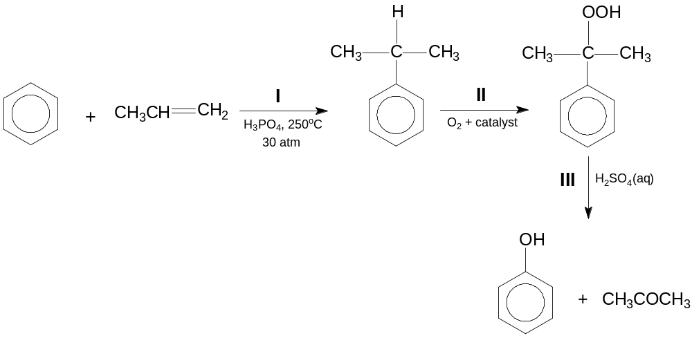

This process illustrates the benefits of chemical engineering as two relatively cheap starting materials, benzene and propene, are converted into two more valuable ones, phenol and propanone.

(i) Name the type of reaction in step I and describe the mechanism for this reaction, including curly arrows showing movement of electrons.

(ii) Describe how the products, phenol and propanone, of the Cumene Process may be separated.
[5]

5. (b) Propanone has many uses. Besides being used as solvents for plastics and adhesives, propanone is also used to produce methyl-2-methylpropenoate, the monomer used for the production of the polymer, Perspex.

Methyl-2-methylpropenoate can be synthesized from propanone in a 4-stage process as shown below.

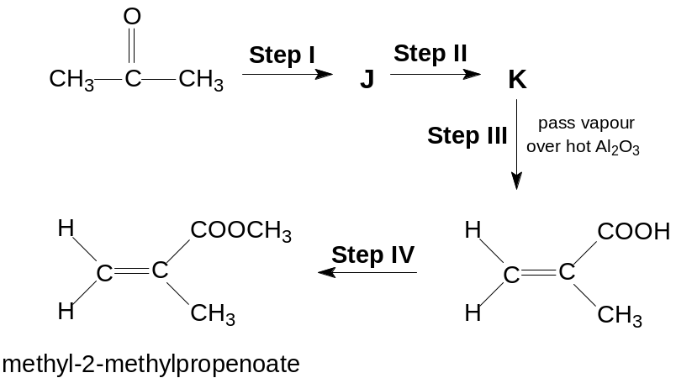

(i) State the reagents and conditions needed for steps I, II and IV.

(ii) Draw the structural formulae of the intermediates J and K.
[5]

5. (c) Propanone reacts with iodine in the presence of acid according to the equation

CH₃COCH₃ + I₂ → CH₃COCH₂I + HI

A student wanted to study the kinetics of the above reaction.

He prepared a mixture containing:

- 5 cm³ of propanone of concentration 1.0 mol dm⁻³,
- 10 cm³ of sulfuric acid of concentration 1.0 mol dm⁻³ ,
- 10 cm³ of a solution of iodine of concentration 1.0 x 10⁻³ mol dm⁻³
- 75 cm³ of distilled water.

At every five minutes interval, 10.0 cm³ samples were removed and 10 cm³ of aqueous sodium hydrogencarbonate was added, followed by a titration against a solution of sodium thiosulfate(VI).

The experiment was repeated using 20 cm³ of sulfuric acid in the reaction mixture.

The following results were obtained.

Time/min |  | 5 | 10 | 15 | 20 | 25
Titre/cm³ | for 10 cm³ acid (expt 1) | 18.50 | 17.00 | 15.50 | 14.00 | 12.50
Titre/cm³ | for 20 cm³ acid (expt 2) | 17.00 | 14.00 | 11.00 | 8.00 | 5.00

- Describe the roles of iodine and sulfuric acid in this reaction.

- Why was sodium hydrogencarbonate added prior to the titration? Can sodium hydroxide be used instead? Explain your answer.

- By means of a graphical method, determine the relevant order(s) of the reaction.

(iv) Calculate the concentration of the sodium thiosulfate(VI) solution used in the titration.

(v) The rate constant for this reaction has units of mol⁻¹ dm³ min⁻¹.

Experiment 1 was repeated using propanone of concentration 0.8 mol dm⁻³. Without doing any calculation, sketch on the same axes in (iii), the graph you would expect to obtain.
[10]

[Total: 20]

